1. **LEGISLATIVE REQUIREMENTS**

Section 16 of the Municipal Finance Management Act (56 of 2003) [MFMA] dealing with the tabling of the annual budget requires that:

* *The council of a municipality must for each financial year approve an annual budget for the municipality before the start of that financial year*
* *For a municipality to comply with subsection (1), the mayor of the municipality must table the annual budget at a council meeting at least 90 days before the start of the budget year*.

**1.1 Council Resolution**

The Council of Dannhauser Municipality to note the Draft Budget on the council meeting that will take place on the 29th of March 2022.

**1.2 Recommendation**

That the following draft budget resolutions in terms of Section 16(2) and 17(3) of the Municipal Finance Management Act, (Act.56 of 2003) be noted for final approval in May 2022.

**1.3 Draft Resolutions**

1. That the following Draft Policies to be noted

* Customer Care, Credit Control and Debt Collection Policy and Bylaw
* Property Rates Policy and By-law
* Tariff Policy and By-law
* Unauthorized, Irregular and Fruitless and Wasteful Expenditure Policy
* Indigent Policy
* Virement Policy
* Cash Management and Investment Policy
* Travel & Subsistence Policy
* Supply Chain Management Policy
* Asset Management Policy

b) The draft annual budget for the financial year 2022/23 to be tabled in March 2022, with the following

1. Capital expenditure by project
2. Operating revenue by source
3. Operating expenditure by type

c) that the tariffs for property rates and other services be noted

* 1. **The South African economy and inflation targets**

The world economy is expected to grow by 4.4 per cent this year. This is lower than the 4.9 per cent that was anticipated when tabling the Medium-Term Budget Policy Statement (MTBPS). The Omicron variant of the coronavirus caused many countries to impose restrictions to manage its spread. In addition, continued imbalances in global value chains have limited the pace of the world’s economic recovery.

The South African economy has not been shielded from these global developments. National Treasury has revised South Africa’s economic growth estimate for 2021 to 4.8 per cent, from 5.1 per cent at the time of the MTBPS. This revision reflects a combination of the impact of changes in the global environment, along with South Africa’s own unique challenges. Commodity prices, which have supported South Africa’s economic recovery, slowed in the second half of 2021.

Also, violence unrest in July 2021, and restrictions imposed to manage the third wave of COVID-19 further eroded the gains South Africa made in the first half of the year. Industrial action in the manufacturing sector, and the re-emergence of loadshedding, also slowed the pace of the recovery. Real Gross Domestic Product (GDP) growth of 2.1 per cent is projected for 2022. Over the next three years, GDP growth is expected to average 1.8 per cent. Headline inflation is expected to remain between 3 to 6 per cent target range over the 2022/23 MTEF.

In summary, the tax revenue in 2021/22 was higher than projections and this was mainly due to commodity price. However, these are projected to be short term, and as such long-term spending commitments should not be made based on short term revenue benefits. There are measures in place to reduce expenditure to narrow the budget deficit. The following macro-economic forecasts must be considered when preparing the 2022/23 MTREF municipal budgets.



1. **Executive Summary**

The municipality had to review its affordability levels and fit its operating and capital expenditures within the affordability levels. This necessitates reprioritisation of expenditure and containing costs in non-essential services.

The municipality needs to apply sound financial management principles and ensure that the municipality remains financially viable and ensures that the municipal services are provided sustainably, economically, and equitably to all wards.

Section 21 of the MFMA provides clear guidance for the entire budget process. National Treasury ‘s MFMA Circular No. 112 and 115 review are used to guide the compilation of the 2022/23 MFMA.

Although the above concepts were considered, challenges arose during the compilation of the draft 2022 MTREF budget, and are summarised below:

* Financial and Human Resources constrains
* Increased demand of basic services
* Implementation of mSCOA throughout the budgeting process as the mSCOA versions keeps on changing and the budget has to be compliant with the 6.6 mSCOA classification framework at some point during the financial year.
* Projects that are budgeted as single year but take multiyear (it creates planning problem and financial problems)
* Virements not catered for by Mscoa
* Mscoa changes not accompanied by proper training

In terms of MFMA Circular No. 115, the new leadership is advised to:

* Decisively address unfunded budgets by reducing non-priority spending and improving revenue management processes to enable collection
* Address service delivery failures by ensuring adequate maintenance, upgrading and renewal of existing assets to enable reliable service delivery.

**Credible Funded Budget**

The community should realistically expect to receive services that are affordable for which provision is made in a budget.

**Amongst other things, a credible budget is a budget that:**

* Funds only activities consistent with the revised IDP and vice versa ensuring the IDP is realistically achievable given the financial constraints of the municipality
* Is achievable in terms of agreed service delivery and performance targets
* Contains revenue and expenditure projections that are consistent with current and past performance.
* Does not jeopardize the financial viability of the municipality i.e. ensures that the financial position is maintained within generally accepted prudential limits and that obligations can be met in the short, medium and long term.

**3. OPERATION REVENUE FRAMEWORK**

The current state of financial affairs of the municipality mandate drastic, difficult, and decisive actions must be taken in terms of tariffs increases and balancing expenditure against planned realistic anticipated revenues. Efficient and effective revenue management is thus critical.

Total operating revenue has increased by R38 million for the 2022/23 financial year when compared to the 2021/22 Adjustment Budget. For the two outer years, operational revenue will increase on average 4 per cent respectively.

The municipality’s main revenue comes from the following:

* Transfers and subsidies (Grants)
* Property Rates
* Licencing Fees (learners, driver’s license, and vehicle licence)
* Refuse Collection

The municipality ‘s revenue management is built around the following:

* National Treasury’s guidelines
* Efficient revenue management
* Property Rates Policy
* Correct valuation Roll

Transfer recognised as operational and capital receipts is the largest revenue source totalling 65 % or an increase of R 8.1 million. This income has been gazetted in the draft Division of Revenue Act and allocation letters received.

Revenue generated from property rates and services charges forms a significant percentage of revenue for the municipality income source. In the 2022/23 financial year, revenue from services charges and property rates totalled R 32 million. The increase is R 2.7 million and will grow at an average annual rate of 4 per cent in the respective outer financial years of the MTREF.

National Treasury continues to encourage municipalities to keep increases in rates, tariffs, and other charges as low as possible.

**3.1 Debt impairment**

The municipality need to make provision for debt impairment because it has an impact on the collection rate at the end of the financial year.

**3.2 Grants (Transfer Recognised)**

The municipality is largely dependent on grants, in fact grants are 64% of the budgeted revenue. Equitable Share amounts to R 108 million and Municipal Infrastructure Grant is R 24 million.



**3.3 Property Rates**

Tariffs for Property Rates have increased as per the CPI of 4.8%. Property Rates proposed amount is R 30 million. Property rates are the largest part of municipal own revenue as it contributes 13% in the total own revenue. The municipality need to ensure that it collects more than 85%, then it will have a positive impact on the cash flow challenges.

**3.4 Service Charges (Refuse collection)**

Service Charges relating refuse removal proposed amount is R 2 million. The tariffs are as follow.

|  |  |  |
| --- | --- | --- |
|  |  |  |
| **Refuse Removal** | CURRENT TARIFF 2021/2022 4.6% | PROPOSED TARIFFS 2022/2023 4.8% |
| Domestic Bind removal INC VAT | 64.75 | 67.86 |
| Business bins 0-4 INC VAT | 157.29 | 164.84 |
| Business bins 5 or more INC VAT | 426.52 | 446.99 |
| Garden refuse (office hours) | 257.55 | 269.91 |
| Garden refuse (after hours) | 777.12 | 814.42 |
| Grass cutting per square meter | 4.37 | 4.58 |

**3.5 Licencing Fees (Driver’s licence, Leaners Licence)**

Traffic department projected to collect an amount of R 960 128.00; the opening of new testing ground will improve the revenue collected for licencing fees.

**3.6 Fines (Traffic Fines**)

Ticket fines are estimated to be R 403 002.00, this is on accrual bases. The municipality need to strengthen collection on issued tickets, going forward to assist with revenue collection.

**3.7 Vat Return**

The municipality estimate vat return to be R 20 million, this is informed by capital projects that the municipality would undertake in 2022/23 financial year. This is an increase because of the number projects budgeted for the period.

**3.8 Interest on Investment**

The municipality used to keep monies in different financial institutions in order to accumulate interest and use it at the later stage but because of cash flow challenges, these investment options have drastically decreased. The projected budget is R 387 739.00

**3.9 Donation ( ZinoJu Mining)**

Zinoju mining pledged to contribute R 5.5 million for infrastructure development in certain areas in Dannhauser, the municipality will also add R 1.5 million. Due to their Mining obligation.

**3.10 Other Revenue**

Other revenue will come from different services that the municipality offers i.e. tender fees, cemetery fees, library fines and other services. Other revenue budget is R 1.2 million.

**3.11 DTI**

There’s funding that the municipality will receive from DTI, for infrastructure development over the MTREF period for Industrial area development.

**4. OPERATING EXPENDITURE FRAMEWORK**

**4.1** **Depreciation and Impairment**

Depreciation is a good barometer of future or current capital financing costs to expand and manage infrastructure. Budget appropriations in this regard total R 22 million for 2022/23 financial year.

**4.2 Contracted Services**

This item is budgeted an amount to R 25,7 million which is a decrease compared to the adjustment budget. This is the work outsourced to service providers, which is under operational budget. The main items are:

* Professional Services
* Outsourced Services

**4.3 Other Expenditure**

Other expenditure comprises of various line items relating to the daily operations of the municipality. This group of expenditure has also been identified as an area in which savings could be made. The budgeted amount for other operational costs is R 26 million. These include insurance, fuel(oil) and bank charges.

**4.4 Repairs and Maintenance**

Municipalities are encouraged the make sufficient budget for infrastructure maintenance, 8% of budget shall be allocated to the maintenance of infrastructure which is a norm. The municipality has budgeted R 13 million for maintenance of infrastructure.

**4.5 Employees Cost**

The budgeted allocation for employee related costs for the 2022/23 financial year totals R 39 million, this is an increase of 4%, which slightly under CPI of 4.8 %. The provision has been made for certain critical posts on the organogram which are advertised.

**4.6 Remuneration of Councillors**

Councillors’ allowances are determined by the Minister of Cooperative Government and Traditional Affairs. The projected budget for Councillors allowances is R 10 million.

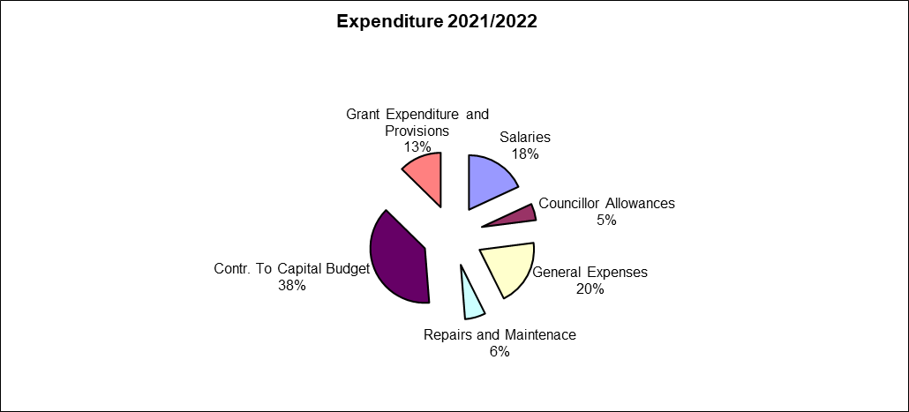

**5. Capital Expenditure**

The Municipal Capital Budget is R 85 million. This is an increased of R 7.7 million or 8 %. Capital Expenditure will be funded by grants and internal funding. The municipality is constrained in its finances, the council need to look at other avenues to fund the capital projects e.g. like doing business plans so that investment can recover satisfactorily.